Safe Flame: Behavior Aware LPG Safety and Consumption Prediction System
Introduction
Some similar work exists upon literature review in 2025 and 2026.These systems are mostly implemented using IoT and AI. Several LPG monitoring and safety systems have been developed in recent years focusing primarily on gas leakage detection and alert mechanism. They typically use gas sensors interfaced with microcontroller, to detect the presence of LPG in the surrounding environment.
Common Features of Existing Systems
- Detection of LPG leakage using gas sensor.
- Activation of alarm on detection.
- Sending notification via GSM/IoT based platform.
- Basic gas level monitoring using load sensors.
- Automatic shut off valves in certain implementations
These systems are largely reactive in nature in case of hazardous condition.
Limitations of Existing System
- Reactive operation
- Lack of context awareness: -gas sensors detect the presence of LPG, but cannot distinguish between normal cooking usage, minor leakage and hazardous leakage. This leads to false alarm.
- Absence of behavioral analysis: -existing systems does not analyze user consumption patter, time-based usage trend and abnormal usage behavior.
- Limited prediction capability: -Only few systems estimate remaining quantity of gas.
- No leak classification: -Most designs cannot differentiate between,
- slow leak –gradual weight loss
- sudden leak –rapid weight loss
- normal usage-time bound usage pattern
Key Enhancement of Proposed System
- Behavior based analysis: -learns daily gas usage pattern and establish baseline for normal operation. Any deviation is treated as anomaly.
- Leakage classification mechanism.
- slow leak –gradual weight loss
- sudden leak –rapid weight loss
- normal usage-time bound usage pattern
- Predictive gas consumption: -using historical data, the system estimates:
- Remaining gas quantity
- Expected duration of availability
- Multi-parameter decision making- the system combines:
- Load cell data (weight change)
- Gas sensor output
- Time-based usage patterns
- Anomaly Detection: -abnormal behaviors such as:
- Gas usage at unusual hours.
- Continuous consumption beyond normal duration.
are identified and flagged.

Algorithm
- Weight change:
Current weight-previous weight
- Rate of change:
ΔW/Δt
- Classification
if Rate>upper threshold=>Sudden risk
if rate>lower threshold => Slow leak
else =>Normal
- Prediction
Remaining days=remaining gas/avg daily usage
- Behavior detection
If usage not in normal time=>Anomaly

Proposed system improves upon existing solution by shifting from reactive detection mode to predictive and behavior aware system by incorporating data analysis, pattern recognition and multi-parameter decision making. Thus, the system enhances safety, reliability, user awareness and preventive capability.
System Level Block Diagram
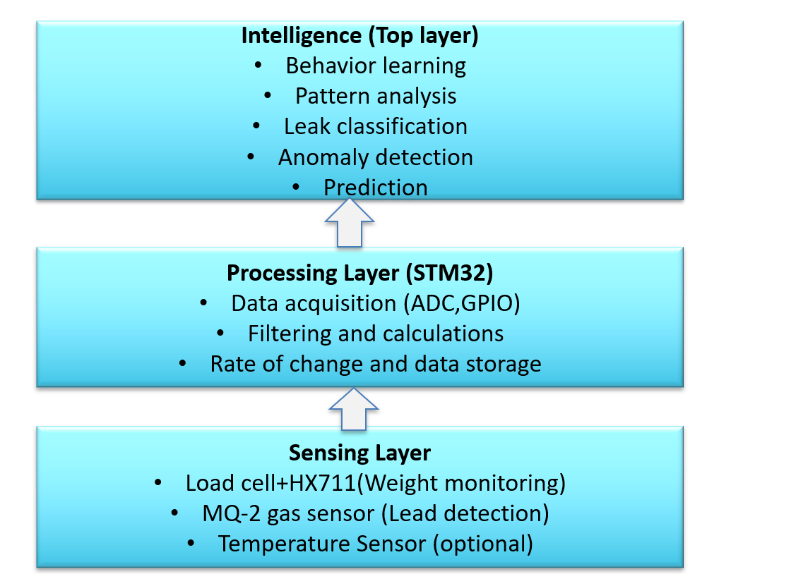

Components Required
- 50 kg load cell with HX711 amplifier
- MQ-2 -LPG sensor
- MQ-4 -Methane sensor
- MQ-7 -CO sensor
- DHT22 -temperature and humidity sensor
LPG leaks are dangerous, but methane and CO are equally hazardous. Methane is a major component of natural gas and CO is a byproduct of incomplete combustion. Detecting all three ensures protection not only from leaks but also from faulty burners or ventilation issues. In kitchen, industrial setup or vehicles LPG and methane can coexist. CO often builds up when LPG burns inefficiently – so monitoring CO helps identify poor combustion or blocked exhaust before they become lethal.
High LPG+ low CO Leak
Normal LPG + high CO Incomplete combustion
High methane + high CO Mixed gas hazard

MQ-2 alone is fine for simple leak detection, but for distinguishing LPG, methane and CO a multi sensor array is used.

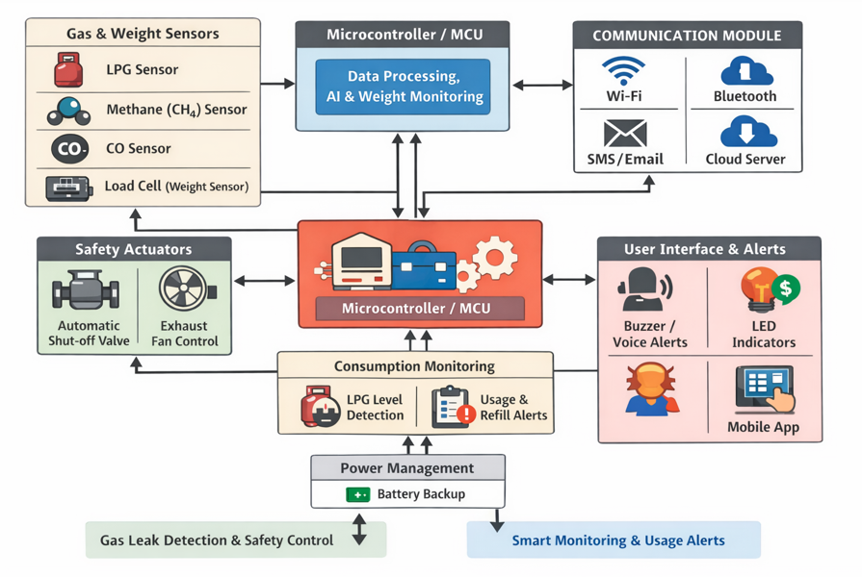
GPIO pin mapping
